# **Bootstrap**

**Materials and resources:**

<https://www.w3schools.com/bootstrap4/>

<https://learn.freecodecamp.org/responsive-web-design/responsive-web-design-principles>

<https://getbootstrap.com/docs/4.1/getting-started/introduction/>

<https://v4-alpha.getbootstrap.com/getting-started/introduction/>

<https://www.tutorialspoint.com/bootstrap/>

<https://medium.freecodecamp.org/learn-bootstrap-4-in-30-minute-by-building-a-landing-page-website-guide-for-beginners-f64e03833f33>

**Assignments:**

Task 1:

Most of the users today use their mobile or tablet to access the web page. So, let’s dive more into responsive design. You have the following mock-up.

1. Implement mockup using only HTML and CSS. No CSS frameworks.
2. Follow the breakpoints that are given in the mockup.

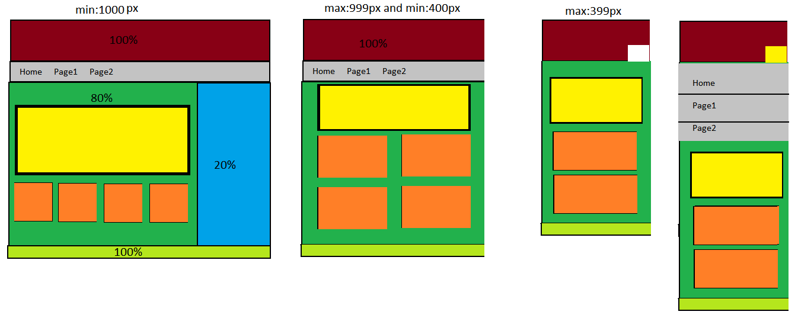

Task 2:

Implement following mockup using the most popular front-end component library bootstrap.

1. Implement the mockup using HTML, CSS and Bootstrap 4.
2. Design: In the real world nothing is black and white, use your imagination!
3. Change the image placeholder with real images.
4. Buttons or links are not leading anywhere.
5. Use Google maps to implement the map.

